De La Salle University – Dasmariñas

College of Science and Computer Studies

Computer Science Department

**Online Billing and Reservation System of**

**Greenfields Paradise Resort in Pangasinan**

Presented to the Faculty of the Computer Studies Department

College of Science and Computer Studies

De La Salle University – Dasmariñas

In Partial fulfilment of the

Requirement for the Degree of

Bachelor of Science in Information Technology

By

Bael, Sheberllie Moira K.

Partosa, Claude Mikhail O.

Naybe, Sean Kyle G.

**Table of Contents**

**Abstract 1**

1. **CHAPTER 1: Introduction**
   1. Background of the Study
   2. Statement of the Problem
   3. Objectives
   4. Significance of the Study
   5. Scope and Limitations
2. **CHAPTER 2: Review of Related Literature**
   1. Local Study
   2. Local Literature
   3. Foreign Literature
   4. Foreign Study
3. **CHAPTER 3: Methodology**
   1. Research Paradigm
   2. Concept of the Study
   3. Conceptual Operation
   4. Development Planning
   5. Evaluation of Projects
4. **CHAPTER 4: Design**
   1. Project Planning
   2. Project Development
   3. Evaluation of the Project
5. **CHAPTER 5: Results and Discussion**
   1. Results
   2. Discussion
6. **CHAPTER 6: Conclusion and Recommendation**
   1. Conclusion
   2. Recommendations

**Bibliography**

**Appendices**

Data flow diagram (existing) – Context and Level 3

Data flow diagram (proposed) – Context and Level 3

Screenshots

Forms from the company

Transcript of interview

Copy of the questionnaire

Photo Documentation (during evaluation and Implementation)

**Abstract**

Online Billing and Reservation System is an online system that manages the billing and reservation transaction of the resort. The customer enables to access the resort’s website through browsers and transact without any hassle of going to the resort. It is one of the most must-have of hotel and resorts stage business for it brings a wide range of possible customer. This system helps the company or owner to attract more customers with the use of our website for their own convenience. Not only the company or owner but also the customers will benefit from the study.The researchers used HTML, CSS for designing the project, JavaScript for function of buttons, PHP for database.

**CHAPTER 1**

**Introduction**

* 1. **Background of the study**

Online Billing and Reservation system is an online system that manages the billing and reservation transaction of the resort. The customer enables to access the resort’s website through browsers and transact with them without and hassle of going to the resort. Online Billing and Reservation system is one of the most must-have of hotel and resorts stage business because it brings a wide range of possible customer. (Leen, 2013)

Hotel and resorts administration are quickly multiplying giving people wide range of choice that is why online billing and reservation is necessary for hotels and resorts establishments in social club to be competitive enough in their field of business. (Leen, 2013)

Greenfields Paradise Resort is a beautiful resort where clients can perfectly experience nature's glory as you relax and enjoy serenity under a canopy of greens and the open skies!

Greenfields Paradise Resort was built on January 28, 2016. Before the resort was built, it was once a poultry owned by a general. The resort is 13.5 hectare big.

Greenfields Paradise Resort offers a swimming pool, 2 storey building with 38 rooms, two unit Gazebo, 60 units Nipa Hut shed, waste water treatment facilities, a generator set, Pump house, Amenities such as one storey hotel extension building (Annex) with 22 rooms, a Conference room, one unit office, two storey building(Pavilion) with one unit function hall and six rooms, one unit Recreation Centre (Game House), one storey building(quarters), Store Building and Zip line stations.

This resort is still unpopular to the tourists. And the proponents’ objective for this project is to make a more convenient way for the clients to see what the resort has to offer and for them to easily book a reservation.

This project intends to help not only the clients but also the owner of the beach house resort. By coming up with a website, the clients will have the taste of what amenities the resort can provide. Also, it will offer them a convenient way to reserve or book especially if they live far. With the help of the website, the beach house resort could attract more clients, making it look more engaging and fun to visit.

**1.2. Statement of the Problem**

Based on our research, the Greenfields Paradise Resort encounters and difficulty in reservation are:

Greenfields Paradise Resort has been using manual reservation and billing system. This manual process produces slow processing of their reservation. Reservation of this resort is done with phone calls which they manually write in the customer’s log book.

Greenfields Paradise Resort is having a problem with **data redundancy**. The reservations is through phone calls, e-mails, walk-in are written repeatedly in their logbook. The resorts only use phone calls as a mode of reservation, which becomes difficult when the customers call simultaneously. Cancelation of reservation are also repeatedly written in their log book.

**Double booking** are the situations when customers need to save on a similar date without realizing that the booked date has been effectively given or held for another customer. All things considered, Conflict in scheduling is faced by the resort. The administration of the resort manages this by giving the reservation to the primary customer who will give their initial installment to benefit the reservation space. In the other hand, different customers will be requested to reschedule, benefit of alternate offices or exchange to different resorts.

**Data loss** is another of their problem. The resort is utilizing a log book for reservation. If the

logbook is lost, the resort does not have any back-up files for the reservation written in the logbook.

The reports required for the resort are not outlined. The owner of the resort only receives receipts and listed reservation on the logbook.

**Security of records** is classified as one of the most important factors when it comes to hotel industry. The records should be secured because it is serves as the weekly, monthly and annual reports of the hotel. The resort’s weekly reports are written only in the logbook which the management cannot monitor their sales because of its redundancy. In addition, paper records are kept in lockable drawers when not in use. This is particular when other people have access in to offices where records are stored and steal it.

Automated records needs to have a password for a protection of databases or stored in a shared drive that only the authorize people will have access to it.

**Security and privacy of customers** is another important factor in hotel industry. The guests and staff’s details should be kept confidential especially credit card numbers that might get hacked. The resort is only using logbooks for the customer’s information which other people might stole their details and use it to another reservations.

By offering secure reservations, the resort gains instant credibility and trustworthiness, as well as safeguarding your reputation.

**With these problems, resort cannot face with other resorts easily and it will continue and leads to bankrupt. The proponents will try to lessen the burdens of the management, improve their reservation system.**

**1.3. Objectives**

**1.3.1 General Objective**

To develop an Online Billing and Reservation for Greenfields Paradise Resort in Cebu

**1.3.2 Specific Objectives**

1.3.2.1 To gather necessary information through interview and research.

1.3.2.2 To analyze the whole and internal process being done in the resort through the use of data flow diagram (DFD).

1.3.2.3 To develop the proposed system using HTML, CSS, PHP language, SQL server and Adobe Photoshop.

1.3.2.4 To have a secured database.

**1.4. Significance of the study**

This study is to help the company or owner to attract more customers with the use of our proposed website for their own convenience. Not only the company or owner but also the customers will benefit from the study, for they can easily do reservations and billings without any hassle. The proponents are to develop an Online Billing and Reservation System for the Greenfields Paradise Resort.

Not only the owner or manager of the resort will benefits this study, it benefits also

their clients.

Company – The proposed system will make the procedure faster and easier. The proponents' have trust that this study will help the Greenfields Paradise Resort enhancing their manual system of billing and reservation by making it online and computerized, quick for the resort.

Manager – This system will lessen the work to be done by the manager because the system can generate report easily

Employees – This will help for the employees to give the clients more accurate information and billing statements with their clients

Clients – This system give them an accurate information and eliminates travel expenses going to and from the resort booking and less hassle for the clients who wants to make reservation through online system.

Proponents - This system serves as a guide for the proponents to use their ability and knowledge in programming and databases.

Future Proponents - This also serves as a reference and guide for the future proponents especially those who wants to conduct a study about Online Billing and Reservation System.

**1.5. Scope and Limitations**

The scope of the study is the Online Billing and Reservation System of Greenfields Paradise Resort. The proposed system covers different processes involving reservation of the resort that deals with the client’s information. This study also covers a database to be included in the system, to assist the administrators and organized way of record keeping.

An automated type of payment and reservation will be offered to the clients’ convenience as they will not to have to pay over-the-counter only if walk-in customers made a reservation personally in the resort.

The billing payment can be process through online transaction of the system. wherein the guest will be required to pay half of the payment for partial or can pay in full. The resort implement a strictly no cancellation policy but guests are allowed to reschedule within two weeks or two days depends on the season before the first booking date or else the reservation fees will be forfeited. The confirmation of reservation will be process through email.

Rebooking of the preferred data can also be done by the clients only with the available days within two weeks or two days depends on the season.

The clients can only stay for twenty-one hours. The time of checking in the resort is two o’clock in the afternoon while check out is twelve o’clock in the morning.

If they want to use amenities like Karaoke, Billiard Table, Rock Climbing, Zipline and Rappelling not included in the package, additional fees will be charged. For cottages there will be an extra charge depends on cottage. Cottages are Calesa, Bahay Kubo (Small) cost P50/hr and P100/hr for Bahay Kubo (Large), Francisca and Feliza Halls. Corkage fee for drinks is P25 to P100 per bottle applies to alcoholic beverages and softdrinks brought inside the Greenfields Paradise Resort premises. The resort sells softdrinks, beers and hard drinks. The resort also have a restaurant and offers a catering for events.

The resort can accommodate up to 100 persons and above. Person exceeding to the room who will not be staying overnight will only be charged P250 per head and if they want an extra mattress there will be extra charged cost P250.

Furthermore, the proponents also include the resort’s vision mission, terms and condition, area information, facility rates, packages, resort’s promo, and the photographs of the resort and facilities that will present as an online advertisement of Greenfields Paradise Resort.

**CHAPTER 2**

**2.0 Review of Related Literature**

This chapter presents related literatures, articles, and studies which support the significance of performing this project of creating a system. This chapter also helps in giving enlightenment about the concept and benefits of this project.

**2.1 Local Study**

**2.1.1 *Online Billing and Reservation System for San Miguel Nature Park Island   
 (Ayson, R. M. U., Austria, Ma. F. R., 2013)***

The San Miguel Nature Island Park Resort is one of the hidden agenda s of Imus. A 2.5 hectare wide resort located at #351 Alapan 1-C in Imus. The land was owned by a dweller from Sta Ana Manila, Gloria Fauni. It was initially planned as racetrack for horses because it was a popular business way back in 90’s and later decided to make a resort. The resort has lot of amenities and it was stated that the public pool can accommodate 100 guests during peak seasons. The system provides reservations, billing process, cancellations and maintenance of their database. By having an automated system, a user-friendly system which lessen the time consumed in making reservations, in calculating bills, and the problems in preserving all essential information about the company.

The proponents will develop a user-friendly system that will also lessen the client’s time in making reservations and billing processes. With the help of the study, it is more convenient and time consuming rather than going to the resort or making phone calls to reach them out.

**2.1.2 *Online Billing and Reservation System of Jardin De Dasmarinas|  
 (Alvaran, N. A. V. et al., 2013)***

This study is about online billing and reservation system of Jardin De Dasmarinas developed by Alvaran, Nikki Andrea, et. Al. is about providing a system for the processing of reservations, billings and maintenance. In addition, it is also to help them gain more customers although, this resort had already gained popularity in Dasmarinas not just by the amenities but also, the developer and the establishment need to have a system to gain more customers and profit.

The proposed study will provide a location since Cebu is known for one of the tourist attractions in the Philippines, it may also help to gain more popularity especially most people nowadays are looking for a resort which will fit to their taste and budget.

**2.1.3 *Online Billing and Reservation System for Circle Island Resort   
 (Bebe, M. G. et al., 2014)***

This study was very informative about the difficulties of dealing manual reservations and how the billing process made. This system covers the processes for reservations, transactions, cancellation and maintenance of the database. Moreover, the security of the data is more important to this study because it covers all the private information for the guests and needs to have a stronger database.

The proposed system is to provide also a stronger database and to avoid the “double booking” issue which is commonly experienced by the resorts nowadays. The proposed system intends to end all errors and loss or redundancy of customer’s reservation and confrmation details.

**2.1.4 *Online Billing and Reservation for Villa Kalikasan Taysan, Batangas  
 (Serra, E. T. et al., 2013)***

This study was about the online reservation and billing system for Villa Kalikasan Taysan, Batangas. It was stated that this system provides list of rooms, cottages and packages, function room and rates so that the users can use this as a main guide for any inquiries the customers may have. It was also stated that the admin has the authorized access to the whole system and will be able to update all the records of customers for reservations made or walk-in customers. The system has also a maintenance in case the resort has added amenities or changes.

The proposed system will be able to update, add and delete some information in the system. This may also help the administrator to monitor who make reservations and who has already made reservations and waiting for confirmations through email or SMS to avoid overlapping of schedules.

**2.2 Local Literature**

**2.2.1 *An Ajax-Based Hotel Management System Implementing Three-Tier Architecture Approach (Camino et al. 2013)***

### According to article, it was mentioned the importance of having an online reservation and billing system. Online billing and reservation system is part of a marketing strategy to boost their profits and give what the customers are looking for. This proposed system by Haniper John B. Camino, Ronald John C. Olalo, Dariza D. Salamo and Lemuel Dominique R. Yap is to provide a centralized billing system, room management and implementing online payments.

### It is a useful tool for the hotel managers as this study could make their hotel or resort competitive. This is also to lessen the time consumed because of the traditional reservation system, this study can quickly finish with just a few clicks.

# 2.2.2 *Biyaheroes: An Online Bus Booking System (Morial, 2017)*

This article is about bus booking system which is more likely similar to hotel in making reservations and transactions. Biyahereos is an online booking service for local travellers for both land sea transportations in the country.

According to the said article, “Like with most online transactions, there are various ways to pay for your ticket. You can conveniently pay with your credit/debit card through PayPal. If you don’t want to use your cards, you can also transact through any major bank via mobile banking, over-the-counter deposit as well as payment centers like LBC, Cebuana Lhullier, SM Bills Payment through Dragonpay. If there’s a 7-11 branch nearby.”

The billing process can be paid using credit card or debit card, pay over-the-counter if the guests doesn’t have any debit or credit cards and they can deposit also through payment centers which was mentioned above.

**2.2.3 *Pinoytravel.com (***[*www.crunchbase.com*](http://www.crunchbase.com)*,* ***2013)***

Pinoy Travel is the first online bus booking in the Philippines. It is both a website and a mobile application that made a partnership to several bus line companies, airline companies and hotels all over the country. Based on the article of [*www.crunchbase.com*](http://www.crunchbase.com), “Aims to make provincial bus reservation/booking as easy and as convenient as booking hotel and air flight.”

“Pinoytravel is the 722,025 site globally based on the amount of traffic with its 54,264 monthly web visitors.” Because of its popularity many customers visits their site that cause web trafficking.

In contrast for the proponents’ proposed system, the proponents’ will assure that even the system gains popularity, customers will not be facing this type of issue especially when the customers are in the part of having their transactions.

**2.2.4 *New Website/app introduces online reservation for local foodies  
 (Lamata and Rubio 2014)***

The article is about online reservation for local restaurants, the app/website called“EatOutManila”. Iñaki Lamata and his cousin Carlos Rubio who introduces the app said “We’ve done bookings that led to frustration—double bookings, cancellations, waiting in line for a confirmed reservation—and we wondered if there was any way we could do this conveniently,” the website or app provides a user access and book their reservations by selecting the restaurant they want, time, date and number of people. Once the user is done, they will receive an email confirmation.

The users will receive an email confirmation once they are done booking with their desired date and time. This will help the customers and the clients to secure their details if it is really them.

**2.3 Foreign Literature**

**2.3.1 *Case Study: Online Reservation System (Cole 2016)***

**According to the article, it describes a client project which integrated Gravity Flow,**[Gravity View](https://gravityview.co/)**and**[Gravity Forms](https://gravityflow.io/out/gravityforms)**to provide an end-to-end online reservation system for a travel company. The Gravity Forms collects all the data while Gravity View displays all the data. “**We intend to extend the system further in the near future with Approval workflows that tie in to a scheduling component and with Web Hooks that trigger external report generation.” (Cole, 2016)

**In this case study, they prefer having their database with the use of Gravity Flow instead of using WordPress-based tools. This case study also provides an account to fill up the reservation and confirmation details.**

**The case study is similar to the proponents’ proposed system that they want to secure their database and the details of the users. Moreover, it is also to reduced data entry errors and increased productivity.**

**2.3.2 *The Benefits of Online Booking Systems (Asenova 2018)***

In this article, it was stated that hotels should have an online booking system because it is part of their goal to sell more rooms, upgrading amenities and make profits. Having an online booking system is more convenient because concierge are no longer to rely on phone calls and walk-in guests just to make reservations. In addition, the system works 24/7 and gives the customers the freedom to book a room anytime they want.

This article gave the proponents an idea to keep track all reservations and all related details. This study will benefit the staff because they won’t be tied to a phone waiting for guest calls especially if the hotel or resort is popular already. The clients will understand all the information of the guests, their preferences and what upgrades the hotel sell the most. It may help the establishment to outline all the areas where they need to focus on and grow their business.

### 2.3.3 *What are the other benefits of an Online Booking System by BookingLive? (Johnston 2017)*

### The article is about BookingLive which is a reservation and booking online system. It was stated that, it provides a scheduling, reservation, and purchasing experiences that create profitable customer relationships. It is trusted by the government departments, retailers and large multinational organizations to manage their most important customer engagement journeys.

### In relation to the proponents’ proposed system, they aim to develop also an online and reservation system that can be trusted by many people. By this, the proposed system of the proponents will also gain more popularity not just the system but also for the establishment.

### 2.3.4 *The rising benefits of online reservations software for hotels (Deist 2013)*

### According to the article, “the accuracy of bookings in booking reservation system, is much higher as user can validate every information at multiple stages before the actual checkout happens.” (Benjamin Deist, 2013) Having a manual booking may cause “double booking” issue because details of the customers may be redundant that even the clients couldn’t understand.

### The proposed system ensures that they will give the customers and clients a stronger database. All the information are accurate and detailed especially for billing processes.

### 2.4 Foreign Study

### 2.4.1 *Online Hotel Reservation System of Hanasonic Hotel in Dansoman, Accra Ghana (Bemile R., Achampong, A., Danquah, E. 2014)*

### The Hanasonic Hotel is a one star hotel. It built to provide accommodation and catering services for tourists and locals. It also engages different activities like crocodile viewing, fishing, bird watching, Monkey playing and there is also a water activity which is boat riding. This study aims to have an online website in order for them to gain more popularity and be one of those competitive hotels in Accra.

### The proposed system want to gain more customers and be competitive like other beach houses in Cebu. Since Cebu is one of a tourist attractions here in the Philippines and made several historical events. People tend to look for a resort which fits their taste and budget.

### 2.4.2 *Measurement of the usability of web-based hotel reservation systems (Shasha 2016)*

### The study is all about to determine the degree of usability of specified Cape Town hotel online reservation system. This system aims to provide a more creative website which can attract users from visiting the website. The developers noted that a well-designed, high quality websites and accurate content create a trustworthy online presence. “Previous research has also shown that a loss of potential sales is possible due to users being unable to find what they want, if poor website design has been implemented. Loss of potential income through repeat visits is also a possibility, due to a negative user experience. “ (Shasha et. al 2016).

### The development of the website will be more creative and assure that the users will attract so that the users may not get bored by just surfing around the website. The system will describe what the hotel or resort is by just looking at the system and how it attracts the customers.

### 2.4.3 *Online Hotel Room and Booking System at Asia Pacific Institute of Innovation and Technology , Malaysia (Hasan et al. 2014)*

### This study was a tasked to create a computerized software titled “Online Hotel Room and Booking System”. The hotel was starting to recognize the problem during that time and the university consult from the hotel analyst to come up with an automated system which will also benefit them for having issues. This study aims to develop a system which is more faster, accurate, and to find errors and seal all those loopholes.

### In terms of finding errors, it is similar to monitor and maintain the database. The proposed system will help the users because of an easy access of the website by booking that even a novice user can interact with it.

### 2.4.4 *Hotel reservation system: Analysis (Pavlov et. al 2015)*

### This study is about the analyzation of developing hotel reservation system and improve its system. The aim of this study is to provide deeper analyzations about the system, search of theories about hotels, reservations and transactions. They also create a small prototype to show how the system work from the user side according to them.

**CHAPTER 3**

**METHODOLOGY**

### The proponents’ proposed system is they have both diagrams which will help the flow of the system. It is important to analyse the system before creating a prototype. The contrast is, the proponent’s proposed system will not develop a small prototype but to develop a real website that serves as a stepping stone for the proponents.

**3.1 Research Paradigm**

The proponents decided to use the V model method for the application, a process development that is an extension of the waterfall model and is based on the association of a testing phase for each corresponding development stage. The model is works well for the smaller projects where requirements are very well understood and is simple and easy to understand and use.

Acceptance Testing

Requirements Analysis

System Testing

System Design

Unit and Integration Testing

Architectural and Module Design

Coding Phase

Figure 3.1 V Model

First Phase: Determine Requirement

The first thing to do is to analyze the user’s needs, what is the most important thing to include in the system. By communicating with the user, we can provide the user requirements document which describes the system’s functionalities, interface, performance, data and security requirements as expected by the user.

We are planning to have an online video call interview with the owner of the proposed resort. Asking questions about the feedback of their past customers about the reservation and payment process, frequent problems that customers leave for them to improve and the history of the resort.

Second Phase: System Design

We’ve come up with a website that will bring ease to the customer as well as the handler, with the server and database in the system, the handler can edit and delete the reservations that had complications. An efficient system that will lessen the problems that might occur in the future.

Third Phase: High and Low-Level Design

In this phase, we will develop the other functions and breaking the system into different kinds of modules. We will develop the data transferring and improve the compatibility of the website to its other modules. Like making the blueprint more detailed and understandable.

Fourth Phase: Coding Phase

In this phase, we will gather all information on each programming language so that we can find the most suitable for the system that we want to develop. After figuring it out, we will continue to the proposed phase and develop the system that will meet the requirements.

Fifth Phase: Unit and Integration Testing

This phase will be the key to make the system’s flow better. We will test the website so that we can see or identify and bugs that needs to be eliminated. Testing also the communications between the internal modules of the system.

Sixth Phase: System Testing

Once the system is developed and tested on its functionalities, we will now test its communication with the external systems. This will determine the software and hardware compatibility issues.

Seventh Phase: Acceptance Testing

After the development and full system testing, we will now present the website to our potential users so that we might know what to improve and include in our system. This phase will also determine the non-functional issues such as the performance defects in the actual user environment.

**3.2 Concept of the Study**

**3.2.1 Input Process Output**

The following IPO Diagram shows and explains the flow of the system.

HTML

CSS

JavaScript

PHP

Implementation of

Online Billing

And

Reservation

For

Greenfields Paradise Resort

INPUT

OUTPUT

PROCESS

Using HTML to define the content of the website. CSS to specify the layout of web pages JavaScript to program the behavior of web pages. PHP a powerful tool for making dynamic and interactive Web pages.

Figure 3.2.2 IPO Diagram

The concept of the study is to give convenience both to the user and to the management of the resort. The researchers are to develop a system that will be online wherein the customers can see the available dates and information that they need while planning to have a reservation of an event or whole reservation of the resort.

**3.3 Conceptual Operation**

The sections below are the process that will happen in using the application.

**3.3.1 Function**

The user will register all his/her necessary information needed, the website will store the collected data to the database of the resort. The moment the user finishes his register to the system, the system will notify the resort manager for its reservation so that they will be updated. After the finishing the registry, the user can now choose their preferred schedule on the available dates, entering the days that they want to avail, the system will perform the necessary computations and will show the user the breakdown of all the payment. The user needs to confirm if their schedule and the price is within their taste, after confirming, the system will now request the billing process. After completing the billing process, the system will email the user for the confirmation for the payment.

**3.3.2 Input Data**

The data for the system is the data that the user will register on our website.

**3.3.3 Output Data**

After the billing process, the resort will send the confirmation for the payment which will be the output data.

**3.4 Development Planning**

**3.4.1 Software Suited for Development**

The software suited for the development of the application is HTML, a basic building block of the Web. It describes and defines the content of a webpage along with the basic layout of the webpage. With the help of PHP, a server-side scripting language designed for Web development, but also used as a general-purpose programming language and CSS to give life on the website’s design.

**3.4.2 Programming /Scripting Language**

The programming language that will be used in developing the system is JavaScript, a high-level interpreted programming language, a language which is also characterized as dynamic, weakly typed, prototype-based and multi-paradigm.

**3.5 Evaluation of the Projects**

**3.5.1 Respondents of the Study**

The proponents selected 40 guests and 20 Employees from Greenfields Paradise Resort, 20 Students inside and outside of De La Salle University – Dasmariñas and 20 IT professionals.

**3.5.2 Research Instruments and Techniques**

The proponents are going to use the Likert Scale on selecting the respondents of the study. The researchers are planning to use the questionnaire as an instrument for the research. By using this we can facilitate data gathering, maximize the time that we have, and we can preserve the confidentiality of the respondent’s reactions and answers. Also, the researchers are planning to conduct interviews to clarify points of information and to verify the information gathered from written sources.

**3.5.3 Data Gathering Procedure**

The proponents are going to conduct an interview once approved and give questionnaires at the Greenfields Paradise Resort and inside and outside of De La Salle University – Dasmariñas. The study is going to be conducted for the preference on what is more efficient, whether if it is better to use the existing system or if it is the online one. They will test the prototype system to see if it is better to use than the existing one.

**3.5.4 Statistical Treatment of Data**

The proponents are looking for the qualitative data by using the questionnaire and conducting interviews as the instruments for the study. The researchers are going to be computing for the percentage if it’s going to give an advantage to use the existing system or the proposed system.

**CHAPTER 4**

**DESIGN**

4.1 Project Planning

The proposed Online Billing and Reservation System that has been developed by the proponents is going to be implemented and used by Greenfield Paradise Resort, Pangasinan. The developed system is the alternate of the manual system used for billing and reservation transactions. The web-based system is accessed via any web browser and the use of internet connection.

4.2 Project Development

The proponents used HTML, CSS and JavaScript for the front-end developing of the system. For the back-end, the proponents used MySQL as a database to provide an easier and more functional system.The proposed system has two users, specifically the administration and the client. The administration has the capability to access the entire system. It can update the records of customers who have been made reservations.The administration has the full control to modify the status of customers reservation and update the list of available facilities on the resort. Also, it can compute the specific total bills beginning from the reservation and all possible add-ons that is made by the customers during their stay in the resort. Generating of reports, part of administration module, displays the list of customers who made reservations, overall facilities reserved, and the total income they gathered during the week.

In creating and accessing reservation, there is a mandatory log in process found in the customers page.

**4.3 Evaluation of the Project**

The data that the researchers have gathered and developed will now test and evaluate the system by the users. The researchers will give questionnaires to the users to know if the researchers meet the their main objective of the project.

**4.3.1 The Questionnaire**

(See Appendix D)

**4.3.2 Respondents of the Study**

The proponents selected 40 guests and 20 Employees from Greenfields Paradise Resort, 20 Students inside and outside of De La Salle University – Dasmariñas and 20 IT professionals.

**4.3.3 Research Instruments and Techniques**

The proponents are going to used the Likert Scale on selecting the respondents of the study. The researchers are planning to use the questionnaire as an instrument for the research. By using this we can facilitate data gathering, maximize the time that we have, and we can preserve the confidentiality of the respondent’s reactions and answers. Also, the researchers are planning to conduct interviews to clarify points of information and to verify the information gathered from written sources.

**4.3.4 Statistical Treatment of Data**

The proponents are looking for the qualitative data by using the questionnaire and conducting interviews as the instruments for the study. The researchers are going to be computing for the percentage if it’s going to give an advantage to use the existing system or the proposed system. The researchers will compute the percentage of every questions to come up with an appropriate interpretation of data. The proponents used the formula for weighted mean as stated as follow:

Where x is the repeating value

w is the number of occurrences of x (weight)

x̄ is the weighted mean

N is the population

**CHAPTER 5**

**RESULTS AND DISCUSSION**

**5.1 Results and Discussion**

|  |  |  |  |  |  |  |  |
| --- | --- | --- | --- | --- | --- | --- | --- |
| 1.0 FUNCTIONALIY |  | 5 | 4 | 3 | 2 | 1 | AVERAGE |
|  | 1.1 The software can perform the tasks required. | 33 | 55 | 12 |  |  | 4.21 |
|  | 1.2 The results is what is expected from the input. | 32 | 50 | 18 |  |  | 4.14 |
|  | 1.3 The software prevents unauthorized access. | 29 | 44 | 27 |  |  | 4.02 |

**Table 5.1.1**

The result for the software can perform the tasks required is 4.21, the results is what is expected from the input, the result is 4.14, the software prevents unauthorized access result is 4.02.

**Table 5.1.2**

|  |  |  |  |  |  |  |  |
| --- | --- | --- | --- | --- | --- | --- | --- |
| 2.0 RELIABILITY |  | 5 | 4 | 3 | 2 | 1 | AVERAGE |
|  | 2.1 The software is capable of handling errors. | 23 | 50 | 27 |  |  | 3.96 |
|  | 2.2 The software resume working and restore lost data after failure | 11 | 53 | 35 | 1 |  | 3.74 |
|  | 2.3 The system allows users to take corrective action once an error has been recognized by the system. | 19 | 34 | 43 | 4 |  | 3.68 |

The result for the software is capable of handling errors is 3.96, the software resume working and restore lost data after failure, many agrees based on the result of 3.74, the system allows users to take corrective action once an error has been recognized by the system, many agrees that users can take corrective action.

|  |  |  |  |  |  |  |  |
| --- | --- | --- | --- | --- | --- | --- | --- |
| 3.0 USABILITY |  | 5 | 4 | 3 | 2 | 1 | AVERAGE |
|  | 3.1 Can easily comprehend how to use the system. | 28 | 45 | 26 | 1 |  | 4.00 |
|  | 3.2 Can easily learn to use the system. | 33 | 37 | 30 |  |  | 4.03 |
|  | 3.3 Can use the system without much effort. | 43 | 40 | 17 |  |  | 4.26 |
|  | 3.4 The interface look good and appealing. | 52 | 36 | 12 |  |  | 4.40 |
|  | 3.5 The use of terms are consistent throughout the system. | 41 | 37 | 22 |  |  | 4.19 |
|  | 3.6 The layout is consistent: | 0 | 0 | 0 | 0 | 0 |  |
| ✓  Function of buttons | 27 | 59 | 14 |  |  | 4.13 |
| ✓  System terminology related to pedagogic tasks | 25 | 54 | 21 |  |  | 4.04 |
| ✓  Consistent positioning of error messages on the screen | 25 | 51 | 24 |  |  | 4.01 |
| ✓  Clear prompts for input | 25 | 54 | 21 |  |  | 4.04 |
| ✓  Informing users of systems progress | 29 | 52 | 19 |  |  | 4.10 |
|  | 3.7 Information (and documentation) is provided by the system can easily be understood. | 27 | 42 | 31 |  |  | 3.96 |

**Table 5.1.3**

The result for can easily comprehend how to use the system is 4.00, can easily learn to use the system, many agrees that it is easy to learn resulting 4.03, can use the system without much effort, result is 4.26, the interface look good and appealing, result is 4.40, the use of terms are consistent throughout the system, result is 4.19, the layout is consistent, divided into 5, function of the buttons is 4.13, system terminology related to pedagogic tasks is 4.04, consistent positioning of error messages is 4.01, clear prompts for input is 4.04 and informing users of systems progress is 4.10, for the last question information is provided by the system can easily be understood is 3.96.

**Table 5.1.4**

|  |  |  |  |  |  |  |  |
| --- | --- | --- | --- | --- | --- | --- | --- |
| 4.0 EFFICIENCY |  | 5 | 4 | 3 | 2 | 1 | AVERAGE |
|  | 4.1 The system quickly respond to commands. | 35 | 36 | 28 | 1 |  | **4.10** |
|  | 4.2 The system provides appropriate response time, processing time and throughput rates when performing the various functions under stated conditions. | 24 | 43 | 32 | 1 |  | **3.58** |
|  | 4.3 Can locate operations and information quickly. | 32 | 36 | 32 |  |  | **4.00** |
|  | 4.4 The software performs a sequence of operation (data input) with economy of motion. | 29 | 38 | 31 | 2 |  | **3.94** |

The result for the system quickly responds to commands is 4.10, the system provides appropriate response time, processing time and throughput rates when performing the various functions under stated conditions, result is 3.58 in favor of agreeing, can locate operations and information quickly, result is 4.00, the software performs a sequence of operation with economy of motion, result is 3.94.

**Table 5.1.5**

|  |  |  |  |  |  |  |  |
| --- | --- | --- | --- | --- | --- | --- | --- |
| 5.0 MAINTAINABILITY |  | 5 | 4 | 3 | 2 | 1 | AVERAGE |
|  | 5.1 The faults can be easily diagnosed. | 29 | 32 | 35 | 4 |  | 3.86 |
|  | 5.2 The software continues functioning if changes are made. | 23 | 32 | 39 | 6 |  | 3.72 |

The results for the faults can be easily diagnosed is 3.86 and the software continues functioning if changes are made, result is 3.72.

**Table 5.1.6**

|  |  |  |  |  |  |  |  |
| --- | --- | --- | --- | --- | --- | --- | --- |
| 6.0 PORTABILITY |  | 5 | 4 | 3 | 2 | 1 | AVERAGE |
|  | 6.1 The software can be moved to other environment. | 25 | 24 | 21 | 29 | 1 | 3.43 |
|  | 6.2 The software can easily be installed. | 23 | 27 | 19 | 29 | 2 | 3.40 |
|  | 6.3 The software can easily replace other software | 26 | 23 | 22 | 27 | 2 | 3.44 |

The results for the software can be moved to other environment is 3.43, the software can easily be installed, result are 3.40, the software can easily replace other software, result is 3.44.

**CHAPTER 6**

**CONCLUSION AND RECOMMENDATION**

**6.1 Conclusion**

In conclusion, the system was timely developed and is designed neatly and is good for the eyes of potential customers, the system will be a great help for the owner and resort staff and the system will provide a more convenient way for the customers to reserve at the Green Fields Paradise Resort.

Based from the results of the questionnaires above, the main objective of the proponents to give a convenient way of making a reservation and a user-friendly system met the said requirements of this project.

**6.2 Recommendation**

The system should often be maintained, thus occurrence of system errors should be reported immediately and directly to the developers. For the entire system to be effective, the manager and the staff as well as the owner should allocate enough time and effort to the system.

The person in charged for the operation and getting used to this system requires to be a full-time employee to have a balanced and constant result.

The proponents recommend this study about Online Billing and Reservation System for resorts or hotels for future reference or use.

Furthermore, the future researchers who decide to develop an Online Billing and Reservation System should spend more time studying further about web development, databases structures etc. because some of the concepts are not taught in classes that will be needed to develop an Online Billing and Reservation System.

**BIBLIOGRAPHY**

Leen, T. (12 September 2013). Online Billing and Reservation System for Hotel De Gloria, Inc. *Prezi*

Camino, H.J. B., Olalo, R.J. O., Salamo, D. D., Yap, L. D. R. 2013. *An Ajax-Based Hotel Management System Implementing Three-Tier Architecture Approach*. Retrieved September 19, 2018 from <https://ejournals.ph/article.php?id=6120>

Morial, D. 2017. *Biyaheroes: An Online Bus Booking System.* Retrieved September 19, 2018 from

[https://www.yugatech.com/cars-transportation/biyaheroes-an-online-bus-booking-system/#sthash.jmdFgXfr.dpbs#doQPd64uA7BOT6Fw.97](https://www.yugatech.com/cars-transportation/biyaheroes-an-online-bus-booking-system/#sthash.jmdFgXfr.dpbs)

Soriano, A. 2013. *PinoyTravel.* Retreived from September 19, 2018 from <https://www.crunchbase.com/organization/pinoytravel#section-overview> and <https://www.pinoytravel.com.ph/story>

Reyes, B. 2015. *New Website/app introduces online reservation for local foodies.* Retrieved September 19, 2018 from <https://www.entrepreneur.com.ph/startup-tips/new-websiteapp-introduces-online-reservation-for-local-foodies>

Cole, G. 2016. *Case Study: Online Reservation System.* Retrieved September 19, 2018 from <https://gravityflow.io/online-reservation-system/>

Asenova, I. 2018. *The Benefits of Online Booking Systems.* Retrieved September 19, 2018 from <https://www.clock-software.com/blog/Benefits-of-online-booking-systems.html>

Johnston, S. 2017. *What are the other benefits of an Online Booking System by BookingLive?* Retrieved September 19, 2018 from <https://www.bookinglive.com/blog/why-use-an-online-booking-system>

Deist, B. 2013. *The rising benefits of online reservations software for hotels.* Retrieved September 19, 2018 from <https://www.gracesoft.com/blog/bid/148976/the-rising-benefits-of-online-reservations-software-for-hotels>

Bemile, R., Achampong, A., Danquah, E. 2014. An undergraduate project of Information Technology Department, Methodist University College Ghana Dansoman, Accra Ghana: *Online Hotel Reservation System of Hanasonic Hotel in Dansoman, Accra Ghana* from <http://www.ijiset.com/v1s9/IJISET_V1_I9_92.pdf>

Shasha, Z. T. 2016.A master degree project: *Measurement of the usability of web-based hotel reservation systems* from Cape Peninsula University of Technology  
<file:///C:/Users/HP/Downloads/0176-masters-thesis-2016-shasha-hotel-website-usability%20(1).pdf>

Hasan, S. et al. 2014. A course thesis assessment: *Online Hotel Room and Booking System at Asia Pacific Institute of Innovation and Technology , Malaysia* from <https://www.researchgate.net/publication/275097517_DOCUMENTATION_OF_ONLINE_BOOKING_SYSTEM>

Pavlov, I. et al. 2015. An undergraduate thesis: *Hotel reservation system: Analysis. “*TALLINNATEHNIKAÜLIKOOL”from file:///C:/Users/HP/Downloads/Hotelli+broneerimise+s%C3%BCsteem%253A+anal%C3%BC%C3%BCs%20(2).pdf

Ayson, R.M.U, Austria, Ma. F.R. 2013. An undergraduate thesis: *Online Billing and Reservation System for San Miguel Nature Park Island* from Thesis Section of De La Salle University- Dasmarinas.

Alvaran, N. A. V. et al. 2013. An undergraduate thesis: *Online Billing and Reservation System of Jardin De Dasmarinas, Cavite* from Thesis Section of De La Salle University- Dasmarinas.

Bebe, M.G. et al. 2014. An undergraduate thesis: *Online Billing and Reservation System for Circle Island Hotel and Resort* from Thesis Section of De La Salle University- Dasmarinas.

Serra, E. T. et al. 2013. An undergraduate thesis: *Online Billing and Reservation System for Villa kalikasan Taysan, Batangas* from Thesis Section of De La Salle University- Dasmarinas.

APPENDIX A

Data Flow Diagram – Level 0

EXISTING SYSTEM CONTEXT DIAGRAM

0

FB and Phone Call Reservation

For

Greenfields Paradise Resort

Additional Fees

Reschedule Request

Resort Reservation

Customer Information

CUSTOMER

Reports

Down Payment

MANAGEMENT

Amenities Reservation

Cancellation Request

DFD LEVEL 1 – Existing System

CUSTOMER

Update Reservation

MANAGEMENT

Logbook

Reservation

Payment

Logbook

Inquiry

DFD LEVEL 2 – Existing System

Update Details

List of Activities

List of Amenities

Customer Details

Reservation Details

Room Type

No. of Rooms

Reports

Confirmation

Official Receipt

Reservation Details

2.0

Reservation

4.0

Update Reservation

MANAGEMENT

Logbook

1.0

Inquiry

CUSTOMER

4.0

Payment

Logbook

Data Flow Diagram – Level 0

PROPOSED SYSTEM CONTEXT DIAGRAM

0

Online Billing

And

Reservation

For

Greenfields Paradise Resort

Reschedule Request

Cancellation Request

Resort Reservation Report

Amenities Reservation Report

Guest Registration

Resort Reservation

Customer Information

CUSTOMER

List of Transactions

Amenities Reservation

MANAGEMENT

Payment

Email Confirmation

Receipt

Guest Lists

Copy of Receipt

DFD LEVEL 1 – Proposed System

Reservation Database

4.0

Payment

1.0

Inquiry

2.0

Registration

3.0

Reservation

CUSTOMER

DFD LEVEL 2 – Proposed system

Customer

Information

Registered Customer

Reservation Details

2.0

Resort Reservation

Reservation Details

Reservation Details

4.0

Payment

Customer Payment

Official Receipt

5.0

Confirm

Reservation

D5 Debit Card Master File

D4 Credit Card Master File

D2 Transaction Master File

D3 Reservation Master File

D1 Customer Master File

1.0

Customer

Registration

CUSTOMER

Check

Availability

Customer Details

Customer

Details

3.0

Amenities

Reservation

Reservation Details

Transaction Details

Confirmed

Reservation

Credit Card Details

Debit Card Details

Reservation Payment

Check

Availability

Confirmation Reservation

MANAGEMENT

D2 Transaction Master File

D8 Rebook Master File

6.0

Update

Reservation

D6 Cancellation Master File

D7 Rescheduling Master File

Reservation Details

List of Customer Report

Customer Details

Cancellation Report

Rescheduling Report

7.0

Report

Generation

Transaction Report

Walk-In Report

DFD LEVEL 3 – Proposed System

Payment

RESORT

Receipt

Account Number

4.3

Deduct

Money

4.2.1

Verify Account Number

Customer Information

Customer Data

D1 Customer Master File

Received Payment

4.2.1

Read Customer Data

Payment

4.1

Payment

CUSTOMER

Confirm Reservation

Paid Reservation

5.3

Reserve Recreational Center

5.1

Reserve Room

Paid Reservation

Paid Reservation

5.0

Confirm

Reservation

Paid Reservation

Paid Reservation

5.4

Reserve Activities

5.2

Reserve Function Hall

Paid Reservation

5.5

Reserve Cottage

Update Reservation

6.2

Reschedule

Reservation

6.1

Cancel

Reservation

6.0

Update

Reservation

6.3

Rebook

Reservation

7.0 Report Generation

7.3

Cancellation Report

7.0

Report

Generation

7.1

Schedules Report

7.4

Transactions Report

7.2

Reschedule Report

7.5

Walk-in Customers Report

**APPENDIX B**

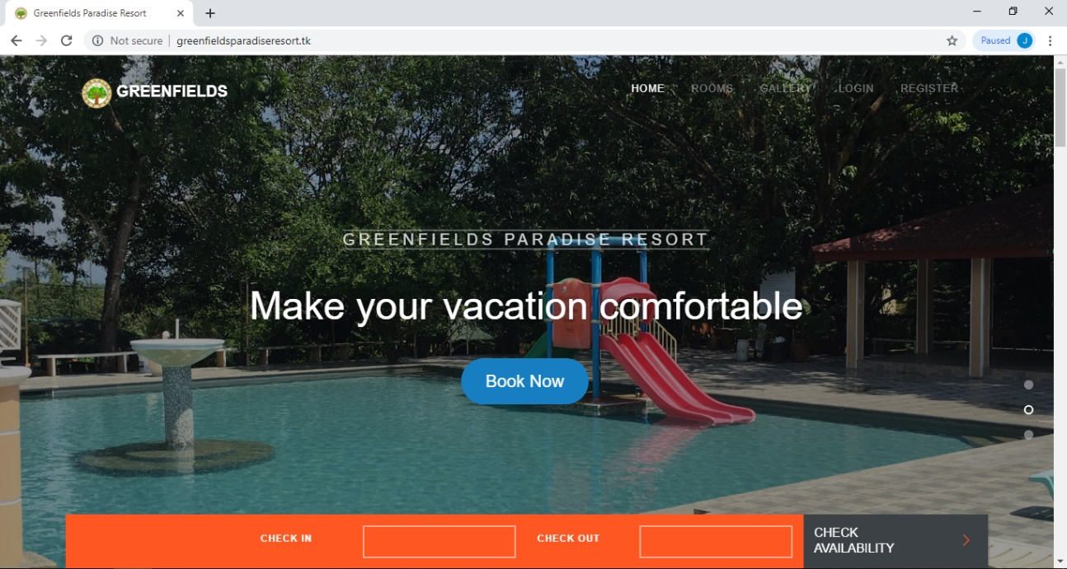**SCREEN DESIGNS**

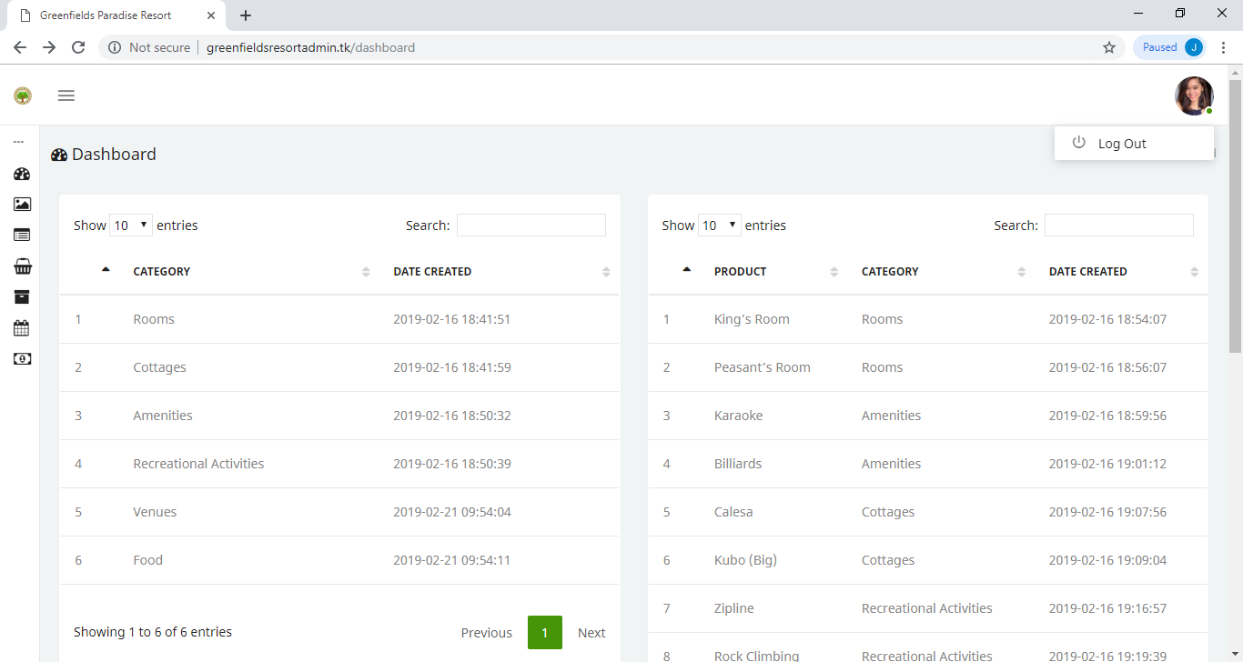**Figure B.1: Greenfields Paradise Resort Home Page**

**Figure B.2: Dashboard of Administrator Page**

**APPENDIX C**

**TRANSCRIPT OF INTERVIEW**

**Sir Mark**: “*Yung history ng resort namin, actually dati ano to eh…ah first na building pa… para kasi ang may-ari nito is General kasi yung may-ari. So, binenta siya kay Mother ko tas ni-renovate. Kasi dating poultry-han kasi talaga to… talagang farm talaga ito.*”

**Researcher**:”*Ilang hectares po to*?”

**Sir Mark**:”*it is 13.5 hectares po*”

*Laughing*

**Researcher**:”*May nakita po kasi akong ni rerenovate pa. Nag rerenovate pa po kayo?*”

**Sir Mark**:”*Yes po*”

**Researcher**:”*Ano pa po balak niyo*?”

**Sir Mark**:”*Yung sa room pa po doon, ay yung sa kabila po is wave pool po.”*

**Researcher**:”*Kelan po siya nag start? Yung pinaka ano.. yung establish nung.*.”

**Sir Mark**:”*Nung nag start siya ng January 28, 2016 siya nag start. So ayun po yung history ng resort namin. Dati talaga wala kaming plano magtayo ng resort talagang minatch lang talaga sa course ko which is HRM. Kaya ayun po*.”

**Researcher**:”*Ahh kakagraduate niyo lang po ng HRM*?”

**Sir Mark**: “*Yes po*”

**Researcher**:” *Saan po kayo nag-aral?”*

**Sir Mark**:”*Sa VMU, San Carlos*”

*vague conversation plus laughing”

**Researcher**:”*So paano po yung cancellation po pati po yung sa reservation process niyo po*?”

**Sir Mark**:”*yung sa pag checheck in namin, minsan kasi ano eh, madalas through email at through phone calls kami. So ang first na tinatanong ko sakanila is kung ano yung pangalan nila, at the same time yung contact number, address then yung kung ilang silang mag checheck in. Minsan kasi may ibang guest na loko-loko din na gumagawa lang. Actually, aminin natin may mga ganun talaga. So, ayun para samin para ma-confirm yung pag checheck in ganun po yung ginagawa naming. Tapos minsan, pumupunta sila ditto na para tignan yung mga kwarto tas ditto na sila mag dodownpayment*.”

**Researcher**:”*Magkano po yung down payment niyo*?”

**Sir Mark:**”*So yung down payment, depende po sa ano, sa rate ng room. Dapat po siya 50% po dapat ang mabayaran nila. Para confirmation na talaga siya na talagang mag che check-in talaga siya or mag a-ano po siya ng mga event namin*.”

**Researcher**:”*Pero may ano po kayo, except po sa down, may mga deposit pa po kayo? Like for example, security deposit mga ganun po*.”

**Sir Mark**:”*actually saamin ang inaano na naming is yung downpayment na kaagad para pag nag ano kasi minsan pag nag aavail ng extra charges doon na naming sinasama kaya hindi na*.”

**Researcher**:”*Ahh! Paano po yun kunwari, for example nag cancel po sila ng pina pa-book po nila, ano po.. hindi na po nila ma rerefund yung 50%?*”

**Sir Mark**:” *Yes hindi na po kasi non-refundable nap o talaga kami. Kasi sinasabi na rin naming po sa mga guest namin yun na mag sesettle sila ng venue or rooms naming is non-refundable na po talaga kasi yung ang nasa rules and regulations namin*.

**Researcher**:”*Yung sa rebooking po, ano po yung time frame? two weeks?*”

**Sir Mark**:”*ahh yung rebooking kahit, samin kasi mga ganitong panahon siguro kahit na two days pwede na pero pag mga summer na sembreak ahh dapat two weeks before dapat meron na sila... Kasi fully booked na lagi lagi. Nag fufully booked to pag summer tsaka sembreak.* “

**Researcher**:”*Ano ano po yung mga positions po ngayon?*”

**Sir Mark**:”*So sa positions po namin may Manager, may front office, may reception, may cook, may hosusekeeping, may guard, may pool master din kami tas meron din kaming mga activities na may master din po dun na aassigned*.”

**Researcher**:”*Sa mga ano po for example pool dito po parang mga life guards?*”

**Sir Mark***:” Dalawa po yung life guards naming. Kung sino po naka assign sa pool master siya rin po yung sa life guard po namin*.”

**Researcher**:”*doon din po sa activities*?”

**Sir Mark**:”*Yes po”*

**Researcher**:”*So dalawa lang salitan lang sila?”*

**Sir Mark**:”*opo salitan lang minsan pag masyado na talagang marami dalawa talaga or 3 kung kailangan po”*

**Researcher**:”*Sa ngayon po ilan rooms po yung meron?*”

**Sir Mark**:”*Sa ngayon lahat ng rooms functional ay 64 po lahat lahat namin*”

**Researcher**:”*yung sa 64 po na yun kasi nakita po naming iba iba po ata yung ano niyo. Sa deluxe po ilan po rooms po meron kayo*?”

**Sir Mark***:” Sa deluxe room po 48 po meron kami*”

**Researcher**:”*Sa executive po ilan*?”

**Sir Mark**:”*is nasa 8 and the rest po supreme na po lahat*”

**Researcher**::”*ahh so wala pa pong family room*?”

**Sir Mark**:”*yung family room po naming is connecting room lang po siya. Connecting siya ng isang deluxe at isang supreme. Connecting room na po siya. Yung sa dormitory naman po nasa 5 po nasa annex po siya na room.”*

**Researcher**:”*okay lang po a mamaya puntahan po yung mga sample po na rin rooms*?”

**Sir Mark**:”*opo wala pong problema*”

**Researcher**::”*kasi isasama po namin sa system niyo yan*”

**Sir Mark**:”*Opo sige po*”

**Researcher**: “*Sa function hall niyo po. Function hall niyo nap o ba yung ano yung mismong hall*?”

**Sir Mark**:”*Yes po. Halos lahat po ng function na po lahat. Yung lagi po nilang kinukuha ditto is yung Epifanio hall po naming which is nasa.. pwede po siyang pumunta ng 150-200 persons depende po sa set-up pa po yun and then yung pinaka expensive po naming is yung pavilion hall kasi pwede siya maging 500-800 po na tao po*.”

**Researcher**:”*Ahh! Ano ano po yung mga, hall lang po talag yung sa pavilion, wala po siyang rooms*?”

**Sir Mark**:” *Yes po, hall lang talaga siya*.”

**Researcher**:”*Pwede ba yung kunwari, ang irerent lang is function hall lang*?”

**Sir Mark**:”*Yes po pwede. Meron din po kaming separate*..”

**Researcher**:”*Separate din po siya kunwari function hall lang po gusto naming so pwede yung functional lang yung babayaran?”*

**Sir Mark**:”*yes po*”

**Researcher**:”*Ahh so separate po lahat pag dating po sa reservations*?”

**Sir Mark**:”*Yes po meron po kaming ganito [forms] sa venue rates po naming andito po lahat po nung ano.. eto lang po yung ibibgay namin. Pag sa venue lang po eto lang po yung babayran po pero pag gusto nila mag swimming ichecheck pa rin po yung entrance fee tsaka po yung sa venue*.”

**Researcher**:”*Ahh*!”

**Researcher**:”*Pwede po ba makahingi kahit isa*?”

**Sir Mark**:”*Opo sige po wala pong problema*”

**Researcher**:”*Salamat po*”

**Researcher**:”*May ano po kayo ngayon yung pang travel and tours po*?”

**Sir Mark**:”*Yes po meron po. Meron po kaming ano po ngayon na parang dadating ngayon Friday. Gab and travel and tours po siya. From Maynila rin po sila kasi kakatawag lang po sakin last week.*”

**Researcher**:”*nag cacater din po kayo ng mga weddings?*”

**Sir Mark**:”*Yes po nag cacater rin po kami nun. Meorn po kami ibinibigay na mga menu po. So pwede niyo rin po siya ipa photocopy*.”

**Researcher**:”*May resto po kayo dito*?”

**Sir Mark**:”*Yes po meron po yang Epifanio resto po natin*”

**Researcher**:”*Yan lang po resto niyo dito*?”

**Sir Mark**:”*yes po ito lang po. So pag breakfast diyan po sila. Pag may mga buffet po dito rin naming sila pinapaano.”*

**Researcher**:”*Kapag po for example nag pa book po ako sa, let’s say sabihin natin executive, may inclusive po kaming apat na mga breakfast*?”

**Sir Mark**:”*Yes po meron po”May free breakfast po plus access na rin po sa pool at the same time meron rin po kaming mga ano po mga promo po na kung gusto po nila mag activities po mag aadditional po sila ng 600 per head meron na po siyang KTV, zipline, wall climbing at tsaka rope rapelling nap o siya*.”

**Researcher**:”*Lahat na po yun kasama na sa 600*?”

**Sir Mark**:”*Opo per head po yun*”

**Researcher**:”*Ah yung sa mga packages niyo po ano po yung ga packages niyo, mga promo..*”

**Sir Mark**:”*ah yung promo lang po naming for swimming kasi po ano eh puro swimming lang entrance fee lang yung 500 po is kasama nap o entrance fee ahh zipline, rope rapeling at wall climbing yun po*”

**Researcher**:”*Yung 500 po na yun per person lang po*?”

**Sir Mark**:”*yes po. Pero yun po yung madalas na kinukuha po nila at the same time kung kaya pa nila mag swimming kasi masyado po mainit nag aactivities po sila*.”

**Researcher**:”*pero wala po siyang free room*?”

**Sir Mark**:”*Wala po*.”

**Researcher**:”*Cottage lang po yung free*?”

**Sir Mark**:”*ahh hindi po mero na pong*..”

**Researcher**:”*Extra charge*?”

**Sir Mark**:”*Yes po extra charge*”

**Researcher**:”*so yung doon po sa 500, entrance fee lang atsaka yung activities lang then acces lang ng pool?”*

**Sir Mark**:”*Yes po*.”

**Researcher**:”*Kapag po sa confirmation po kunwari nag aano po kayo ng mga phone calls. Paano niyo sila cino-confirm through email nalang din po?*”

**Sir Mark**:”*ahh actually po ang amdalas po na ginagawa kop o kasi is tumatawag po sila then tatanunging ko kung kelan sila mag papa reservation kung kailanagn po nila mag pa confirm kailangan po nila pumunta rito para magpa downpayment. Yun po para confirmation po siya. Para hindi po siya ano kasi minsan mag mag papareserve tapos di pala siya pupunta eh may naka abang na mga guest po naming so parang nasasayang rinpo kami. Kaya ganun po ginagawa na process po naming pag ano po ng reservation*.”

**Researcher**:” *eh ano po kayo may mga sample logs po kayo? Na for example po may mga nag pa reserved po*”

**Sir Mark**:”*Yes po mam meron po*”

**Researcher**:”*Tas ano po yung billing niyo ah wala kayo yung like, through bank*?”

**Sir Mark**:”*Ahh actually, ang prinoprocess po sa ano po sa credit card kasi yun ang madalas na hinaharap po nila yung credit card. Pero minsan din po may nagbabayad dito ng check samin pero sa iba po puro sila cash*.”

**Researcher**:”*May mga nagbayad rin po sa inyo ng mga remittance ganun*?”

**Sir Mark**:”*Ah wala pa naman po*”

**Researcher**:”*Okay lang po ba Makita na po mga amenities niyo*?”

**Sir Mark**:”*Sige po*”

**APPENDIX D**

**COPY OF THE QUESTIONNAIRE**

**QUESTIONNAIRE FOR SOFTWARE EVALUATION**

**NAME: (optional) ______________________________________ AGE: __________**

Please rate the software as follows:

5 – Strongly Agree 4 – Moderately Agree

3 – Agree 2 – Disagree

1 – Strongly Disagree

|  |  |  |  |  |  |  |
| --- | --- | --- | --- | --- | --- | --- |
| **RATING** |  | **5** | **4** | **3** | **2** | **1** |
| **CRITERIA** |  |  |  |  |  |  |
| 1.0 FUNCTIONALIY | 1.1 The software can perform the tasks required. | 33 | 55 | 12 |  |  |
|  | 1.2. The results is what is expected from the input. | 32 | 50 | 18 |  |  |
|  | 1.3 The software prevents unauthorized access. | 29 | 44 | 27 |  |  |
| 2.0 RELIABILITY | 2.1 The software is capable of handling errors. | 23 | 50 | 27 |  |  |
|  | 2.2 The software resume working and restore lost data after failure | 11 | 53 | 35 | 1 |  |
|  | 2.3 The system allows users to take corrective action once an error has been recognized by the system. | 19 | 34 | 43 | 4 |  |
| 3.0 USABILITY | 3.1 Can easily comprehend how to use the system. | 28 | 45 | 26 | 1 |  |
|  | 3.2 Can easily learn to use the system. | 33 | 37 | 30 |  |  |
|  | 3.3 Can use the system without much effort. | 43 | 40 | 17 |  |  |
|  | 3.4 The interface look good and appealing. | 52 | 36 | 12 |  |  |
|  | 3.5 The use of terms are consistent throughout the system. | 41 | 37 | 22 |  |  |
|  | 3.6 The layout is consistent | 0 | 0 | 0 | 0 | 0 |
| ✓  Function of buttons | 27 | 59 | 14 |  |  |
| ✓  System terminology related to pedagogic tasks | 25 | 54 | 21 |  |  |
| ✓  Consistent positioning of error messages on the screen | 25 | 51 | 24 |  |  |
| ✓  Clear prompts for input | 25 | 54 | 21 |  |  |
| ✓  Informing users of systems progress | 29 | 52 | 19 |  |  |
|  | 3.7 Information (and documentation) is provided by the system can easily be understood. | 27 | 42 | 31 |  |  |
| 4.0 EFFICIENCY | 4.1 The system quickly respond to commands. | 35 | 36 | 28 | 1 |  |
|  | 4.2 The system provides appropriate response time, processing time and throughput rates when performing the various functions under stated conditions. | 24 | 43 | 32 | 1 |  |
|  | 4.3 Can locate operations and information quickly. | 32 | 36 | 32 |  |  |
|  | 4.4 The software performs a sequence of operation (data input) with economy of motion. | 29 | 38 | 31 | 2 |  |
| 5.0 MAINTAINABILITY | 5.1 The faults can be easily diagnosed. | 29 | 32 | 35 | 4 |  |
|  | 5.2 The software continues functioning if changes are made. | 23 | 32 | 39 | 6 |  |
| 6.0 PORTABILITY | 6.1 The software can be moved to other environment. | 25 | 24 | 21 | 29 | 1 |
|  | 6.2 The software can easily be installed. | 23 | 27 | 19 | 29 | 2 |
|  | 6.3 The software can easily replace other software | 26 | 23 | 22 | 27 | 2 |

**APPENDIX E**

**PHOTO DOCUMENTATION OF EVALUATION AND DOCUMENTATION**

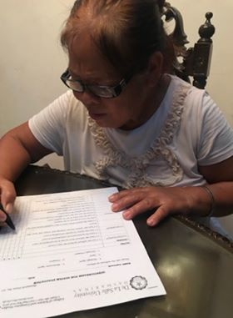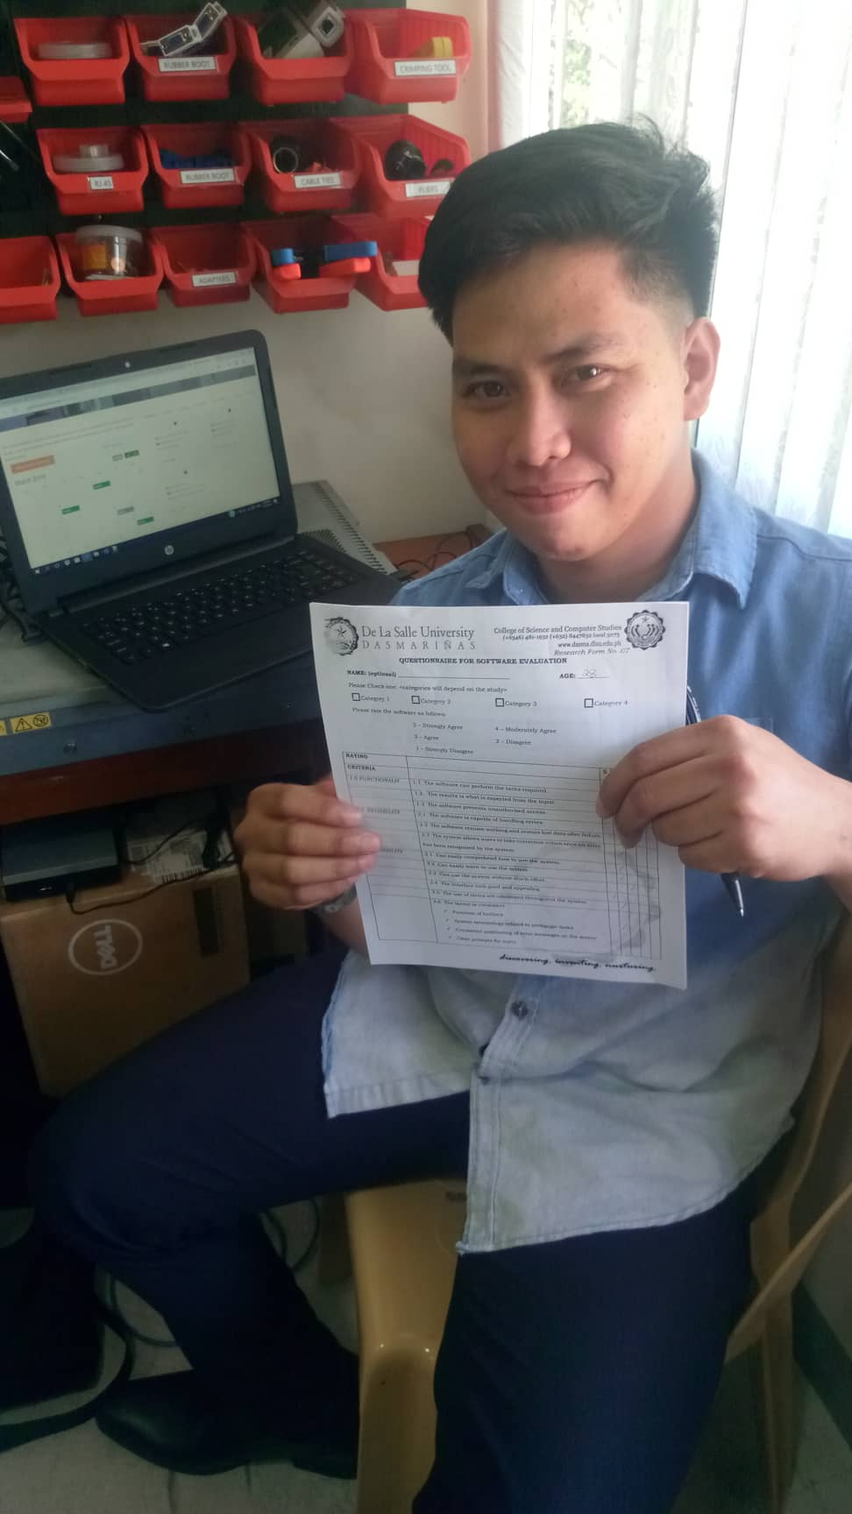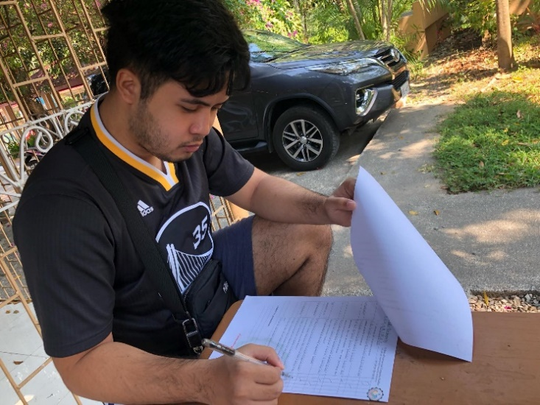

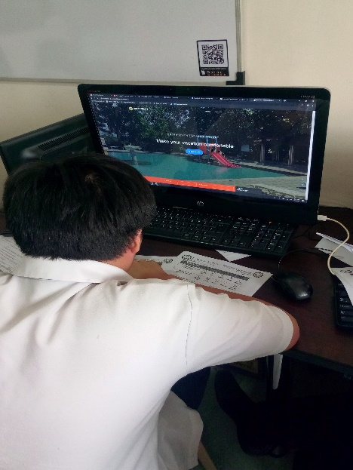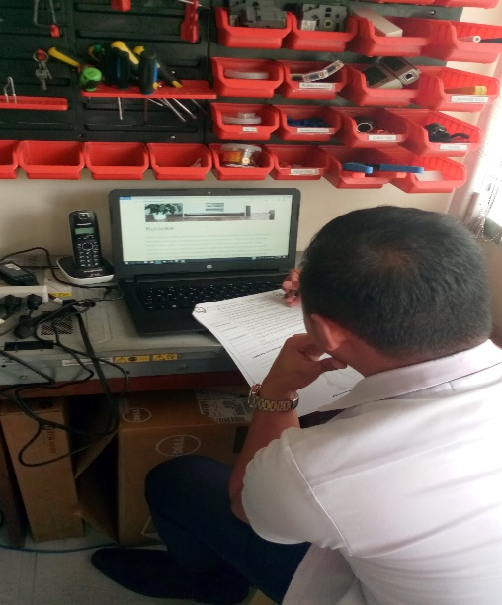

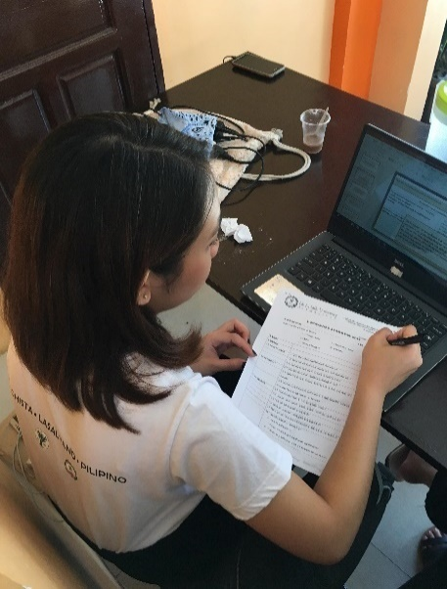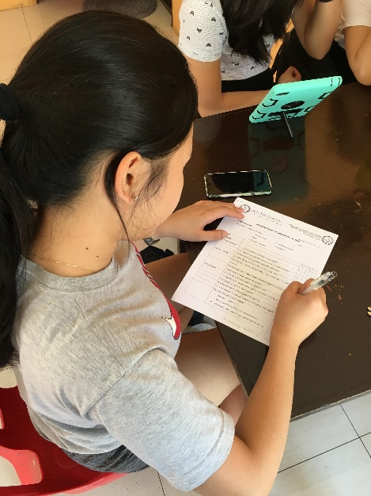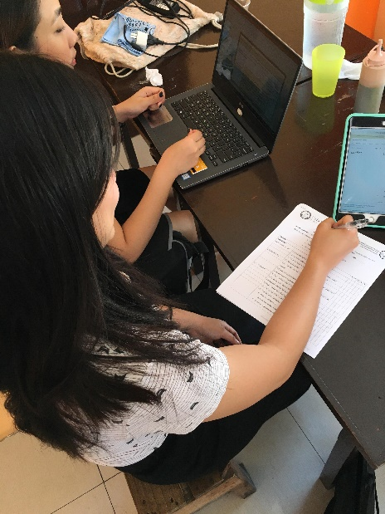

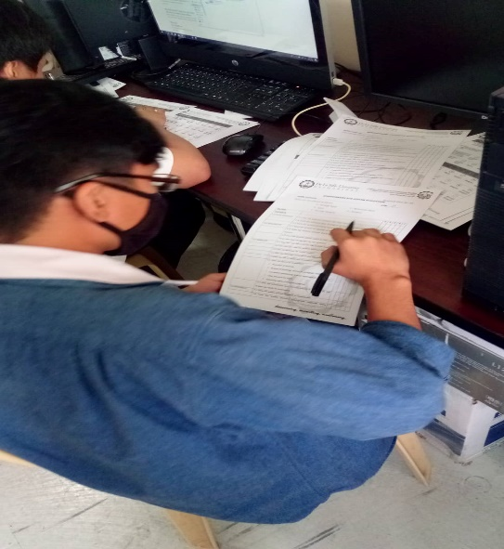

**APPENDIX E**

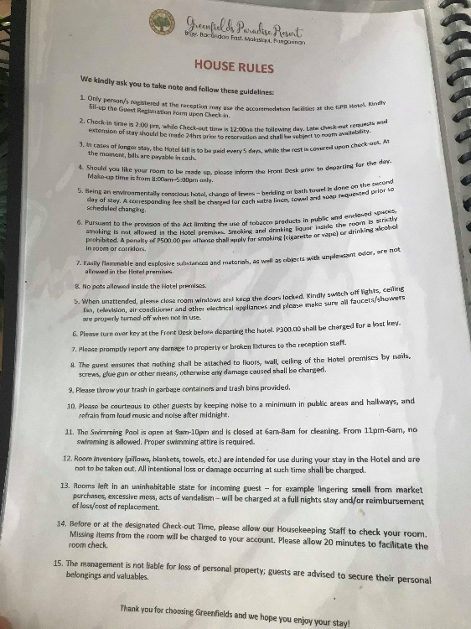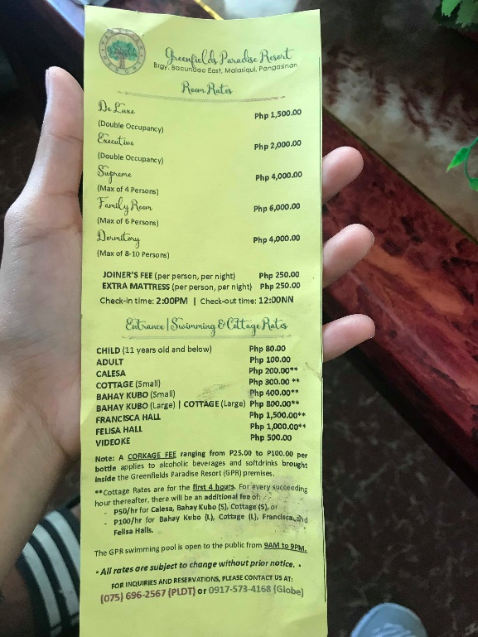**FORMS**

